Correct

Incorrect

Enter PSID and password

Bank Staff login screen

Password:

Client-end validation

Submit – button CSS, onClick event trigger

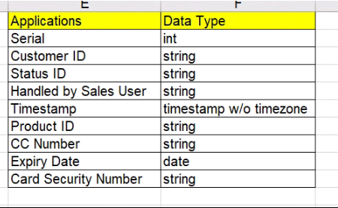

Onboarding Landing Screen

|  |  |  |  |  |  |  |  |  |
| --- | --- | --- | --- | --- | --- | --- | --- | --- |
| Serial No. | Customer ID | Status ID | Sales User PSID | Time Stamp | Product ID | Credit Card No. | Expiry Date | Card Security Number |
|  | 10-digits  unique |  |  |  |  | ??1st digits |  | ?? |
|  |  |  |  |  |  |  |  |  |

**Download**

csv **BUTTON**

**Edit (UPDATE)**

Application **BUTTON**

**Create** New

Application **BUTTON**

ALERT!

Existing Client. Registered.

Customer ID

Entry Screen

Enter unique Customer ID

Existing Customer

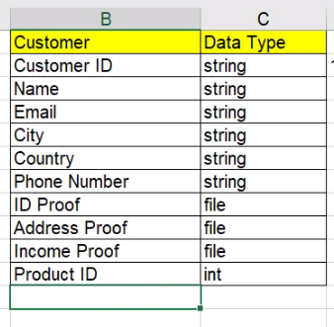

**NOT** Existing Customer

New Application Screen

|  |  |  |  |  |  |  |  |  |  |
| --- | --- | --- | --- | --- | --- | --- | --- | --- | --- |
| Customer ID | Name | Email | City | Country | Phone NUmber | ID Proof | Address Proof | Income Proof | Product ID |
| 10-digits  unique |  |  |  |  |  |  |  |  |  |

Submit (CREATE)

New application

**Edit**

Application **BUTTON**

NEW Application Serial ID added & displayed.

|  |  |  |  |  |  |  |  |  |  |
| --- | --- | --- | --- | --- | --- | --- | --- | --- | --- |
| Serial No. | ₒ | Customer ID | Status ID | Handled by Sales User | Time Stamp | Product ID | Credit Card No. | Expiry Date | Card Security Number |
|  | Radio button | 10-digits  unique |  |  |  |  | ??1st digits |  | ?? |
|  | Select to edit row |  |  |  |  |  |  |  |  |

Radio button appear to select 1 field

SUBMIT

(UPDATE)

Display (READ)

Updated Application info